**C3 - S3 - HOMEWORK**

* Exercise 1 - Find information (write down the name + print screen):
  + find the top 5 **search engines** with the **logos** and the **companies** that create those search engines



Gibiru

Aol

Neeva

Yandex

Gabriel Weinberg

* + **Search** the word **'Angkor Wat'** in those 5 **search engines**.

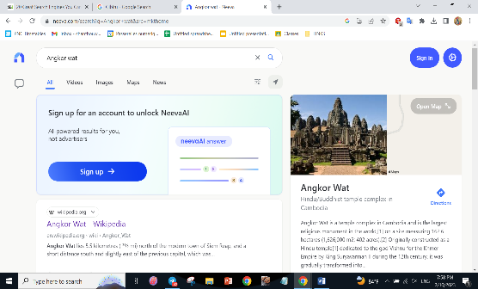

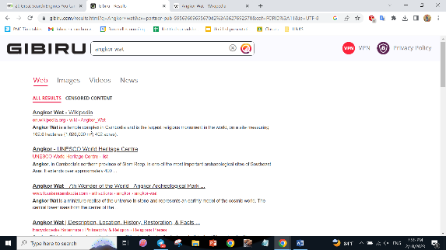

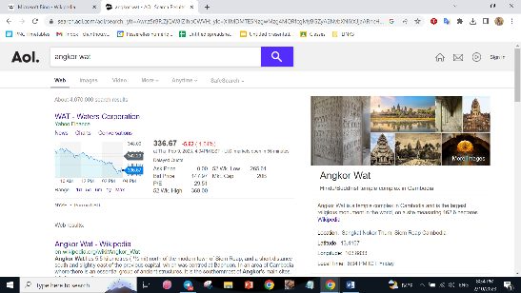

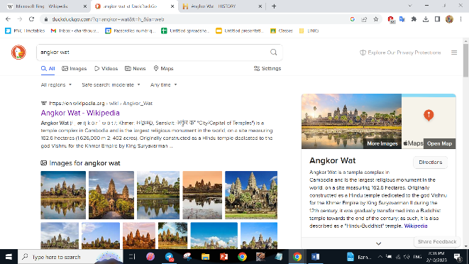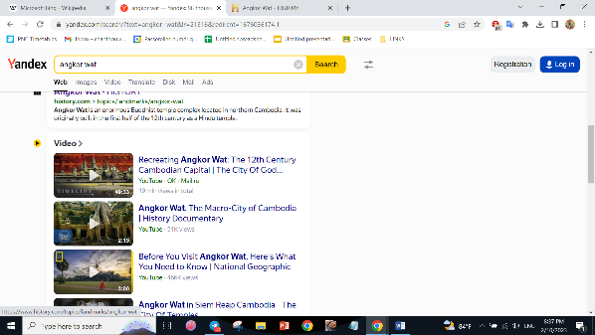

* Exercise 2 - Search **websites** in **Cambodia** as below (Drop the URL of each website):
  + 3 **job findings** websites:
    - <https://pelprek.com/?sp=1>
    - <http://www.topjobcambodia.com/>
    - <http://jobs.phnomlist.com/>
  + 3 **Online shop** websites:
* <https://larue.com.kh/>
* <https://www.similarweb.com/apps/top/google/store-rank/kh/shopping/top-free/>
* <https://aeononlineshopping.com/>
  + 3 **Government** websites:
* <https://opendevelopmentcambodia.net/topics/government/>
* <https://en.wikipedia.org/wiki/Politics_of_Cambodia>
* <https://globaledge.msu.edu/countries/cambodia/government>
  + 3 **News** websites:
* <https://www.khmertimeskh.com/>
* <https://www.phnompenhpost.com/>
* <https://btv.com.kh/>